POLYNOMIALS
Search terms related to the polynomials from the clues given below and shade them using different colours.
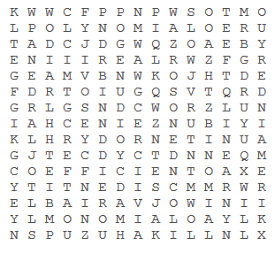

CLUES:
1. The number that remains when the division is not exact
2. An algebraic expression which has variables with non-negative integer exponents only.
3. In division the number being divided into
4. A quantity that can vary in value
5. The constants appearing in a polynomial
6. A polynomial of degree zero
7. A collection of rational and irrational numbers
8. A polynomial with two terms
9. A polynomial of degree three
10. The value of the variable for which the polynomial becomes zero is known as;
11. A polynomial of degree one
12. The value of the variable which satisfies an equation is known as;
13. A polynomial with three terms
14. An equation which is valid for all values of its variables
15. A polynomial having one term
16. The highest power of a variable in a polynomial:

